
Department of Computer Science & Engineering
STUDENT PROFILE
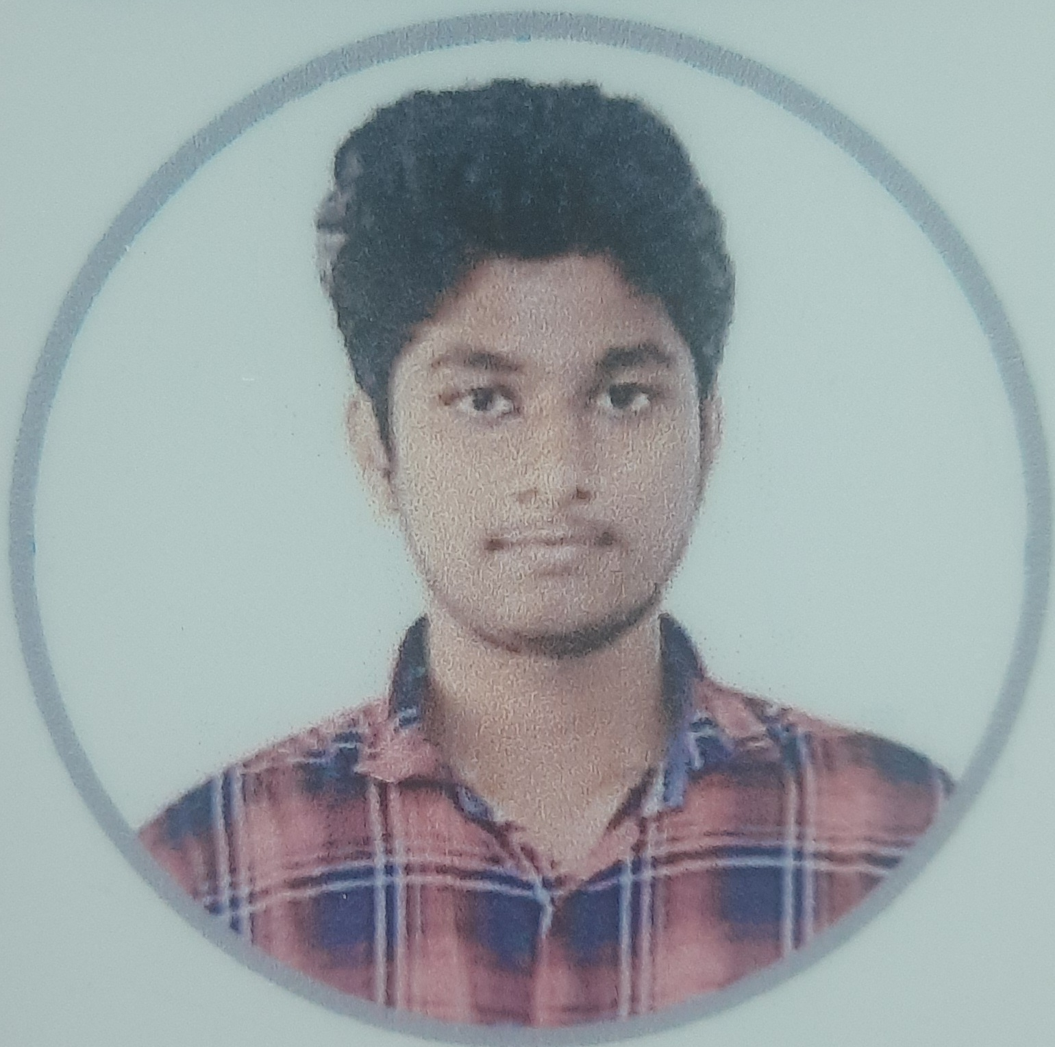
NAME : AJAY.S
REG NO : 20TD0803
BATCH : 2020-2024
DOB : 16.08.2002
AGE : 21
GENDER : MALE
NATIONALTY : INDIAN
RELIGON : HINDU
AMBITION : SOFTWARE ENGINEER
FATHER NAME : SHANMUGAVEL.V
FATHER OCCUPATION : GOVT EMPLOYEE
MOTHER NAME : SARASWATHY.S
MOTHER OCCUPATION : HOME MAKER
SIBLINGS : 1
ADDRESS : NO.16, JEEVANANDHAM ST. , LAWSPET, PUDUCHERRY

STUDENTS MOBILE NO. : 8754857015
PARENTS MOBILE NO. : 9789424715
BLOOD GROUP : B+
EMAIL ID : ajay20td0803@svcet.ac.in
AADHAAR NO. : 4661 5100 7940
EXTRA SKILL : PROGRAMMING

Student Signature Parents Signature

